Explainable Offline Reinforcement Learning for Personalized Breast Cancer Screening and Follow-Up Scheduling Using Longitudinal Mammography Data

Solution Approach
The proposed framework develops an Explainable Offline Reinforcement Learning system for personalized breast cancer screening and follow-up scheduling using the NLBS (Newfoundland and Labrador Breast Screening) dataset. The framework integrates deep learning, Markov Decision Process (MDP) modeling, Offline Reinforcement Learning, uncertainty estimation, and Explainable AI to generate clinically interpretable screening recommendations.

Step 1: Data Acquisition
Mammography images and screening metadata are collected from the NLBS dataset. The dataset includes exam-level information such as age, laterality, view position, and screening outcomes, which support longitudinal patient analysis.

Step 2: Data Preprocessing and Feature Extraction
Mammography images undergo preprocessing including normalization, resizing, noise removal, and augmentation. Metadata is cleaned, encoded, and aligned with image data to form a structured patient-level representation.

Step 3: Breast Cancer Risk Prediction
A deep learning model such as ResNet, DenseNet, or EfficientNet is used to extract imaging features and estimate the probability of future breast cancer occurrence. The output is a patient-level risk score.

Step 4: Patient State Construction
A patient state is constructed by combining risk scores, demographic attributes (such as age), and longitudinal screening history derived from NLBS records. This state represents the patient’s condition at a given time.

Step 5: Markov Decision Process Formulation
The screening problem is modeled as a Markov Decision Process (MDP) consisting of state (S), action (A), reward (R), transition probability (P), and discount factor (γ). This formulation enables sequential decision-making for screening policies.

Step 6: Offline Reinforcement Learning
Historical NLBS screening trajectories are used to train a Conservative Q-Learning (CQL) model. The model learns optimal screening policies without interacting with real patients, ensuring safe and stable learning.

Step 7: Uncertainty Estimation
Prediction confidence is estimated to evaluate the reliability of recommendations. Low-confidence cases are flagged for clinical review.

Step 8: Explainable AI Module
SHAP-based explainability is applied to identify the most influential features affecting each recommendation, improving transparency and clinical trust.

Step 9: Personalized Screening Recommendation
The system generates personalized screening intervals and follow-up recommendations based on patient risk profiles, historical screening patterns, and learned RL policy.

Methodology Flow
NLBS Dataset (Newfoundland and Labrador Breast Screening Dataset)
↓
Data Preprocessing
↓
CNN-Based Risk Prediction
↓
Longitudinal Patient State Construction
↓
MDP Formulation
↓
Offline RL (Conservative Q-Learning)
↓
Uncertainty Estimation
↓
SHAP-Based Explainability
↓
Personalized Screening & Follow-Up Recommendation

Block Diagram
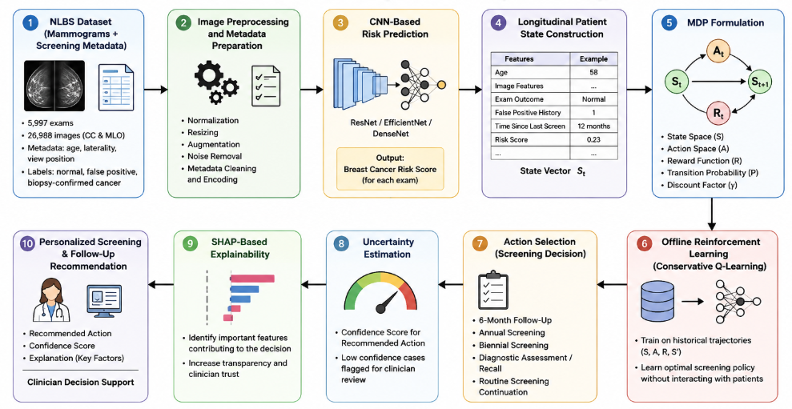

1. NLBS Dataset Input Module
This module collects mammography images and screening metadata from the NLBS dataset. It includes exam-level information such as age, view position, laterality, and screening outcomes, which form the base for analysis.

2. Image Preprocessing and Metadata Preparation
This stage performs preprocessing of NLBS mammography images such as normalization, resizing, denoising, and augmentation. The associated metadata is cleaned, encoded, and structured to create a consistent dataset for model training.

3. CNN-Based Risk Prediction Module
A deep learning model (CNN like ResNet or EfficientNet) analyzes mammography images and predicts the probability of breast cancer. The output is a risk score for each screening exam.

4. Longitudinal Patient State Construction
The risk score is combined with patient-level screening information to form a state vector. This represents the patient’s current health and screening history in a structured format.

5. MDP Formulation Module
The patient state is converted into a Markov Decision Process (MDP) consisting of states, actions, rewards, transitions, and discount factor. This enables reinforcement learning for sequential decision-making.

6. Offline Reinforcement Learning Module
A Conservative Q-Learning (CQL) model is trained using historical NLBS screening data. It learns an optimal policy for recommending screening actions without interacting with real patients.

7. Action Selection Module
The trained policy selects the best screening decision for each patient, such as 6-month follow-up, annual screening, or diagnostic referral.

8. Uncertainty Estimation Module
This module calculates the confidence level of each recommendation. Low-confidence cases are flagged for further clinical review.

9. Explainable AI Module
SHAP is used to identify which features influenced the model’s decision. This improves transparency and trust in the system.

10. Personalized Screening Recommendation Module
The final output provides a personalized screening plan, including the recommended action, confidence score, and explanation for clinical use.

Algorithm
Input:
- $M$: Longitudinal mammography images from the NLBS dataset
- $D$: Screening metadata associated with each exam (age, laterality, view position, exam label, false-positive label)
- $H$: Historical patient screening trajectories
- $A$: Screening action space
Output:
- $R$: Personalized screening / follow-up recommendation
- $CS$: Confidence score of recommendation
- $E$: Explanation for selected recommendation

Algorithm Steps
Step 1: Acquire mammography images and associated screening metadata from the NLBS dataset.
Step 2: Organize the data patient-wise and chronologically to construct longitudinal screening histories.
Step 3: Preprocess each mammography exam by applying image normalization, resizing, augmentation, and noise removal.
Step 4: Extract image-level feature representations from the mammograms using a convolutional neural network (CNN).
Step 5: Train a breast cancer risk prediction model using the mammographic images and available screening metadata.
Step 6: For each patient exam, compute a breast cancer risk score.
Step 7: Construct the patient state representation as
Sₜ = {Ageₜ, Image Featuresₜ, Exam Outcomeₜ, False Positive Historyₜ, Time Since Last Screenₜ, Risk Scoreₜ}
where:
Ageₜ = patient age at time t
ImageFeaturesₜ = CNN-derived mammographic feature vector
ExamOutcomeₜ = current screening outcome
FalsePositiveHistoryₜ = previous false-positive screening history
TimeSinceLastScreenₜ = interval since last mammography exam
RiskScoreₜ = predicted breast cancer risk score
Step 8: Define the screening action space as
A = {A₁, A₂, A₃, A₄, A₅}
where:
A₁ : 6-month follow-up
A₂ : Annual screening
A₃ : Biennial screening
A₄ : Diagnostic assessment / recall
A₅ : Routine screening continuation
Step 9: Formulate the personalized screening problem as a Markov Decision Process (MDP) represented by
M = (S, A, P, R, γ)
where:
S = state space
A = action space
P = state transition probability
R = reward function
γ = discount factor
Step 10: Define the reward function to maximize early cancer detection and minimize delayed diagnosis, unnecessary recall, and excessive screening burden.
Step 11: Construct offline trajectories from historical screening records in the form
τ = (Sₜ, Aₜ, Rₜ, Sₜ₊₁)
Step 12: Train an Offline Reinforcement Learning model using Conservative Q-Learning (CQL) on the historical trajectories.
Step 13: Learn the optimal personalized screening policy
π*(Sₜ) = arg max Q(Sₜ, A)
Step 14: For each patient state, select the optimal screening action recommended by the learned policy.
Step 15: Estimate the uncertainty / confidence score of the selected action to measure recommendation reliability.
Step 16: Apply SHAP-based explainability to identify the most influential factors contributing to the selected screening recommendation.
Step 17: Generate the final personalized recommendation R, confidence score CS, and explanation E.
Step 18: Return R, CS, and E.

Novelty Statement
This study presents an Explainable and Uncertainty-Aware Offline Reinforcement Learning framework for personalized breast cancer screening and follow-up scheduling using the NLBS mammography dataset. The proposed approach combines mammography-based risk prediction, patient state representation derived from NLBS screening metadata, Conservative Q-Learning, uncertainty estimation, and explainable AI techniques to generate clinically interpretable screening recommendations. Experimental evaluation on the NLBS dataset demonstrates the potential of the framework to improve screening efficiency while maintaining transparency and reliability in clinical decision-making.

